Ideation Phase
Empathize & Discover

Date | 01 September 2026
Team ID | Individual Project
Project Name | Software Installation Request Automation in ServiceNow
Maximum Marks | 4 Marks

Empathy Map Canvas:
An empathy map is a simple, easy-to-digest visual that captures knowledge about a user's behaviours and attitudes. It is used here to understand the employee/requester who needs software installation through ServiceNow.

It is a useful tool to better understand the user's goals, concerns, behaviour and challenges before designing the software-request automation solution.
Creating an effective solution requires understanding the true problem and the person who is experiencing it. The exercise of creating the map helps participants consider things from the user’s perspective along with his or her goals and challenges.
Example:
Empathy Map

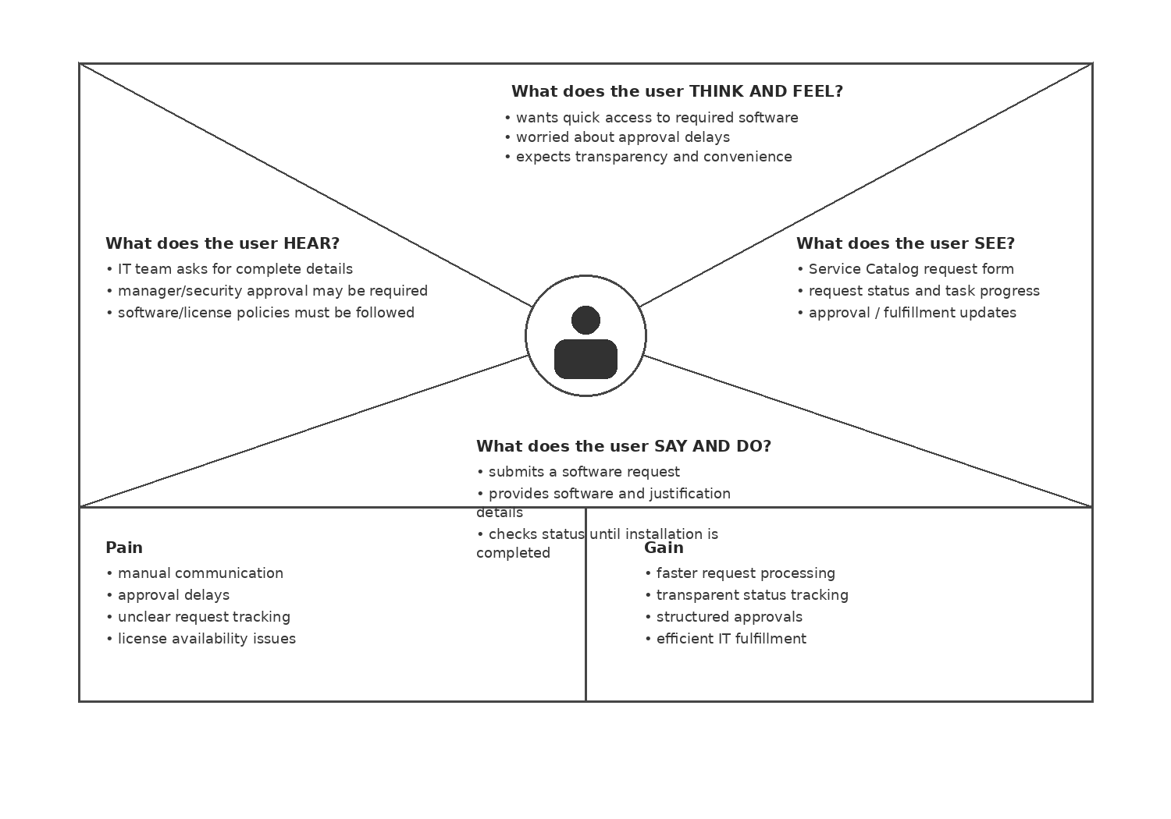

Reference: https://www.mural.co/templates/empathy-map-canvas

Example: Software Installation Request Automation



